Conjectures:

⇒ (implies)

e.g. x = 4 ⇒ x2 = 16

⇔ (equivalent)

e.g. x= ±4 ⇔ x2= 16

Quantifiers:

:(For all)

: ( real set)

**Z:** (integer set)

∈: (element)



∃ : (there exists)

e.g. ∃x∈**Z**

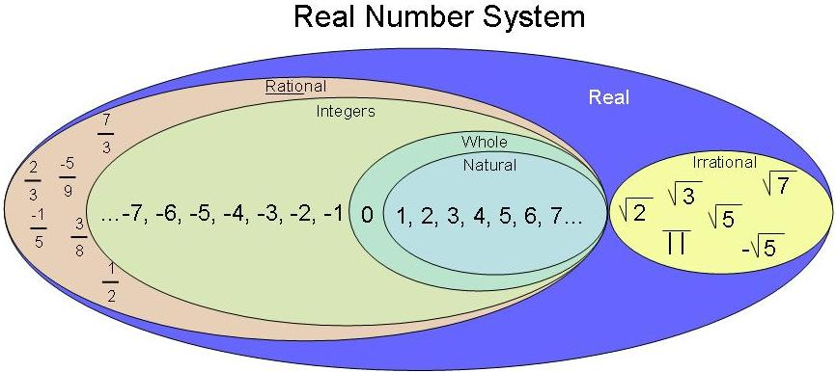

Implications: ⇒ one way

Equivalence: ⇔ two-way

Converse:

** Works for most definitions

P⇒Q

Converse is Q⇒P

Is when the hypothesis and conclusion of a statement is switched. However, the converse of a true statement need not be true

e.g. if x=2 then x2=4 is true

if x2= 4 is false (because x could be -2)

Although if the statement are true they are equivalent statements can be written ‘ P if only Q’

e.g. A triangle has two sides of the same length if and only if it has two angles in size.

Contrapositive:

P⇒Q

The contrapositive is “If not Q then not P”

Is when the hypothesis and the conclusion of a conditional statement is switches and then negating both.

e.g. if x=2 then x2 then x2=4

Contrapositive statement: if x2 ≠4 then x ≠2

The contrapositive of a true statement is also true

e.g. if a polygon has exactly 4 sides then the polygon is a quadrilateral (True statement)

If a polygon is not a quadrilateral then it does not have exactly four sides (The contrapositive is also true)

Inverse:

P⇒Q

The inverse statement is: if not P then not Q

Negating both the hypothesis and the conclusion of a conditional statement.

Negation: (not)

If P is the statement

It is raining

Then the negation of P is the statement:

It is not raining

Assume the opposite and prove the opposite wrong

e.g. the statement:

*You cannot have a right-angle triangle with one side of length 3x cm, another side length (4x+5) cm and the longest side of length (5x+4)*

Assume the opposite

Assume that we can indeed have a right-angle triangle with the given side lengths and the prove that this assumption leads to something that cannot be true.

Pigeon-Hole Principles:

If there are n pigeon holes, n **1, and n+1 pigeons go in them, then at least one pigeon hole must get two or more pigeons.**

e.g. a letterman has 7 letters, but there’s only 6 letter boxes. Therefore, one of the letter boxes will have at least 2 letters.

Concluding

Thus for this statement if P then Q

The *converse* statement is if Q then P

The *contrapositive* is if not Q then not P

The *inverse* statement is if not P then not Q

* The *contrapositive* statement involves both the effect of the *converse*, in its switch of P and Q, and the *inverse*, with its negations of both P and Q
* If the original statement is true then the *contrapositive* is also true but the *converse* and the *inverse* may not be